Working Equitation Yarra Valley Inc.
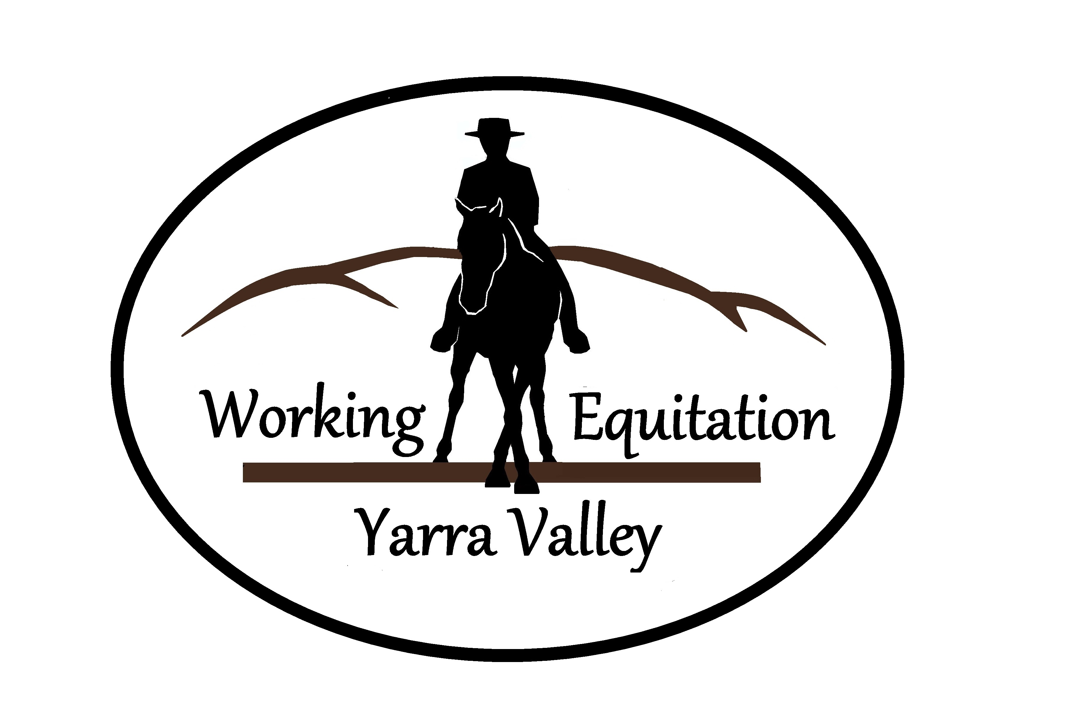
Test Practice Day
Obstacle Rounds - Style
Saturday 18th June 2016
Indoor at Gruyere
ANWE Tests

Training tests run under the rules of HRCAV and
Australian National Working Equitation Inc. (ANWE) Rules
Riders may do two rounds of the Obstacle Course – one after the other.
(Judged on harmony, accuracy and style with judges feedback after each round)

VENUE: 33 Maurice Road Gruyere
COST: $45 for 2 rounds at the same level. (Includes judges feedback)
BOOKINGS & PAYMENT: WEYV Online Booking Form
Bank: Bendigo Bank Lilydale BSB 633-000 Account: 151477684 Ref: Surname / Tests

WORKING EQUITATION TESTS (ANWE) Obstacles - Style Phase:
Introductory – walk/trot (Suit HRCAV level 5 or 4)
Preliminary – walk/trot/canter (Suit HRCAV level 4 or 3)
Intermediate – walk/trot/canter (Suit HRCAV level 3,2 or 1) if enough interest.

TIMES & COURSE MAP: Will be emailed to riders by Lisa Saunders: lisaandian@bigpond.com

NOTE:
This day will run similar to competition conditions but without the formality.
- Run under the new ANWE Rules: http://www.anweltd.com.au/rule-book.html
- Riders may enter the same level test twice, on the same horse.
- Horses must be 4 years or over.
- HRCAV Membership and Dressage Performance cards to be presented on the day
- Riders to provide their own saddle cloth numbers
- Approved safety helmets and footwear to be worn. Club uniform is optional.
- Riders present for gear check 20 mins before their test

